Name : Ganesh G

Subject: Java Internship (25 Sep 2023 – 25 Oct 2023)

Phone : +91 8095912681

Email : [ganeshg2k3@gmail.com](mailto:ganeshg2k3@gmail.com)

**Week - 3 Internship Task**

**Expense Tracker**

During my third week of internship, I was given the task of creating a program for tracking expenses.

Introduction :

I've created a basic Java program for an expense tracker that collects user input for adding expenses and can generate different outputs, such as displaying expenses, total expenses by category, and total expenses by date.

Program :

import java.io.*;  
import java.text.ParseException;  
import java.text.SimpleDateFormat;  
import java.util.ArrayList;  
import java.util.Date;  
import java.util.Scanner;  
  
class Expense implements Serializable {  
 private String description;  
 private double amount;  
 private String category;  
 private Date date;  
  
 public Expense(String description, double amount, String category, Date date) {  
 this.description = description;  
 this.amount = amount;  
 this.category = category;  
 this.date = date;  
 }  
  
 public String getDescription() {  
 return description;  
 }  
  
 public double getAmount() {  
 return amount;  
 }  
  
 public String getCategory() {  
 return category;  
 }  
  
 public Date getDate() {  
 return date;  
 }  
  
 @Override  
 public String toString() {  
 SimpleDateFormat dateFormat = new SimpleDateFormat("yyyy-MM-dd");  
 return "Date: " + dateFormat.format(date) +  
 ", Description: " + description +  
 ", Amount: " + amount +  
 ", Category: " + category;  
 }  
}  
  
public class ExpenseTracker {  
 private ArrayList<Expense> expenses;  
 private static final String *DATA_FILE* = "expenses.ser";  
  
 public ExpenseTracker() {  
 expenses = new ArrayList<>();  
 loadExpensesFromFile();  
 }  
  
 public void addExpense(Expense expense) {  
 expenses.add(expense);  
 saveExpensesToFile();  
 System.*out*.println("Expense added successfully.");  
 }  
  
 public void viewExpenses() {  
 if (expenses.isEmpty()) {  
 System.*out*.println("No expenses recorded yet.");  
 } else {  
 System.*out*.println("Expense List:");  
 for (Expense expense : expenses) {  
 System.*out*.println(expense);  
 }  
 }  
 }  
  
 public double getTotalExpensesByCategory(String category) {  
 double total = 0;  
 for (Expense expense : expenses) {  
 if (expense.getCategory().equalsIgnoreCase(category)) {  
 total += expense.getAmount();  
 }  
 }  
 return total;  
 }  
  
 public double getTotalExpensesForTimePeriod(Date startDate, Date endDate) {  
 double total = 0;  
 for (Expense expense : expenses) {  
 Date expenseDate = expense.getDate();  
 if (expenseDate != null && expenseDate.after(startDate) && expenseDate.before(endDate)) {  
 total += expense.getAmount();  
 }  
 }  
 return total;  
 }  
  
 private void saveExpensesToFile() {  
 try (ObjectOutputStream oos = new ObjectOutputStream(new FileOutputStream(*DATA_FILE*))) {  
 oos.writeObject(expenses);  
 } catch (IOException e) {  
 e.printStackTrace();  
 }  
 }  
  
 private void loadExpensesFromFile() {  
 try (ObjectInputStream ois = new ObjectInputStream(new FileInputStream(*DATA_FILE*))) {  
 Object obj = ois.readObject();  
 if (obj instanceof ArrayList) {  
 expenses = (ArrayList<Expense>) obj;  
 }  
 } catch (IOException | ClassNotFoundException e) {  
 // If the file doesn't exist or cannot be read, ignore the error.  
 }  
 }  
  
 public static void main(String[] args) {  
 Scanner scanner = new Scanner(System.*in*);  
 ExpenseTracker expenseTracker = new ExpenseTracker();  
  
 while (true) {  
 System.*out*.println("Expense Tracker Menu:");  
 System.*out*.println("1. Add Expense");  
 System.*out*.println("2. View Expenses");  
 System.*out*.println("3. Total Expenses by Category");  
 System.*out*.println("4. Total Expenses for Time Period");  
 System.*out*.println("5. Exit");  
 System.*out*.print("Enter your choice: ");  
  
 int choice = scanner.nextInt();  
 scanner.nextLine(); // Consume the newline character  
  
 switch (choice) {  
 case 1:  
 System.*out*.print("Enter description: ");  
 String description = scanner.nextLine();  
 System.*out*.print("Enter amount: ");  
 double amount = scanner.nextDouble();  
 scanner.nextLine(); // Consume the newline character  
 System.*out*.print("Enter category: ");  
 String category = scanner.nextLine();  
 System.*out*.print("Enter date (yyyy-MM-dd): ");  
 String dateString = scanner.nextLine();  
  
 try {  
 SimpleDateFormat dateFormat = new SimpleDateFormat("yyyy-MM-dd");  
 Date date = dateFormat.parse(dateString);  
 Expense newExpense = new Expense(description, amount, category, date);  
 expenseTracker.addExpense(newExpense);  
 } catch (ParseException e) {  
 System.*out*.println("Invalid date format. Please use yyyy-MM-dd.");  
 }  
 break;  
 case 2:  
 expenseTracker.viewExpenses();  
 break;  
 case 3:  
 System.*out*.print("Enter category: ");  
 String categoryInput = scanner.nextLine();  
 double categoryTotal = expenseTracker.getTotalExpensesByCategory(categoryInput);  
 System.*out*.println("Total expenses for category " + categoryInput + ": " + categoryTotal);  
 break;  
 case 4:  
 System.*out*.print("Enter start date (yyyy-MM-dd): ");  
 String startDateStr = scanner.nextLine();  
 System.*out*.print("Enter end date (yyyy-MM-dd): ");  
 String endDateStr = scanner.nextLine();  
  
 try {  
 SimpleDateFormat dateFormat = new SimpleDateFormat("yyyy-MM-dd");  
 Date startDate = dateFormat.parse(startDateStr);  
 Date endDate = dateFormat.parse(endDateStr);  
  
 double timePeriodTotal = expenseTracker.getTotalExpensesForTimePeriod(startDate, endDate);  
 System.*out*.println("Total expenses for the time period: " + timePeriodTotal);  
 } catch (ParseException e) {  
 System.*out*.println("Invalid date format. Please use yyyy-MM-dd.");  
 }  
 break;  
 case 5:  
 System.*out*.println("Exiting Expense Tracker. Thank You!");  
 scanner.close();  
 System.*exit*(0);  
 default:  
 System.*out*.println("Invalid choice. Please select a valid option.");  
 }  
 }  
 }  
}

Sample Input and Output :

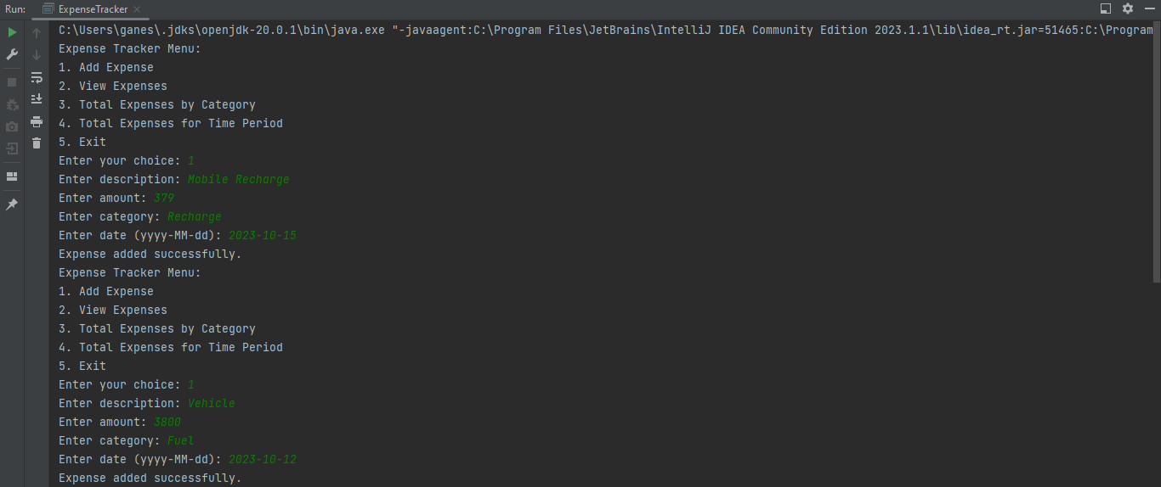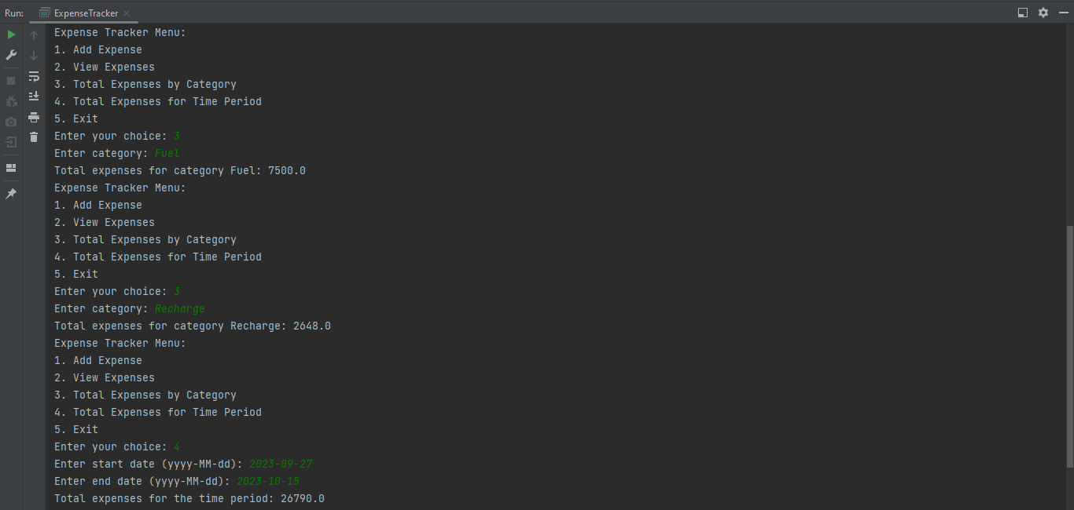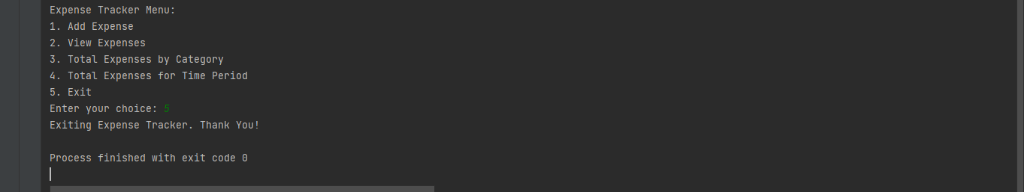

Conclusion :

The Java Expense Tracker program I created is a useful tool for keeping track of your spending. It lets you add your expenses and easily see a list of what you've spent money on. You can also find out how much you've spent in different categories and during specific time periods. The program is easy to use and makes sure your information stays saved even when you close it.